**COA25-01 202 E Main St,** Kenneth Butler Memorial Soup Kitchen in partnership with the Sister Cities of Greenfield Organization is proposing to install a mural on the west façade of their building in celebration of the Sister Cities organization and our Sister City of Kakuda, Japan.

|  |
| --- |
|  |

**Exhibits:**

1. Mural Mockup
2. Current Conditions Picture

**Location and Surrounding Uses:**

North DT Downtown & Historic District – Commercial Auto Repair

South DT Downtown & Historic District – Commercial

East DT Downtown & Historic District – Commercial

West DT Downtown & Historic District – Parking Lot

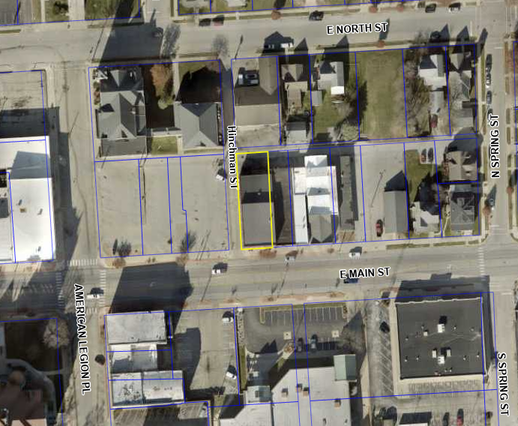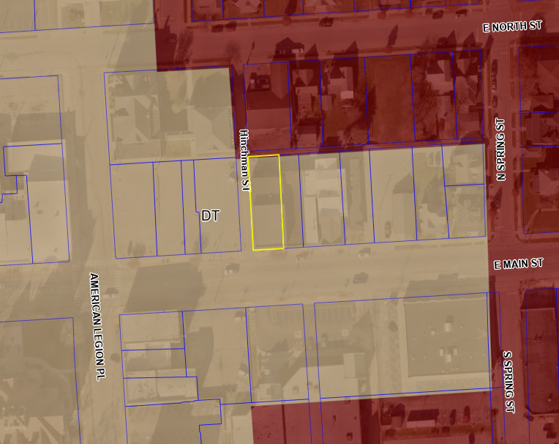

**Aerial Site Location Zoning Site Location**

**CURRENT CONDITIONS**

The east side of the building at 202 E Main Street is a blank terracotta-color painted brick wall with a number of small windows as well as a secondary entrance doorway. The windows and doors all have white trim. The lot between this façade and N East St is an open parking lot used primarily by Greenfield Christian Church. This open parking lot provides clear visibility to the west façade of 202 E Main St from E Main St, where this mural is proposed to be installed.

**Current Proposal**

The Petitioner proposes to have the west façade wall cleaned, primed, and painted with an artistic mural celebrating Greenfield and its Sister City of Kakuda, Japan, as depicted in the exhibit provided.  
  
**Historic Board – COA**Per the Historic Preservation Code 155.10.F*, “Certificates of appropriateness shall be granted if the Historic Board determines that the proposed action is not obviously incongruous with the historic district and shall not be granted if the proposed action is obviously incongruous with the historic district. In determining whether a particular proposal is obviously incongruous with the historic district, the Historic Board shall take into account the purposes of this chapter, the visual compatibility standards contained in this chapter, the historic and architectural significance of the structure and the effect of the proposed change in diminishing or enhancing the significance, the effect of the proposed change on the streetscape, the effect of the proposed change on surrounding structures, and the effect of the proposed change on the district as a whole. The Historic Board shall act in a manner which preserves the visual aspects of the architectural and historic character of the district by assuring that obviously incongruous changes are not allowed.”*  
  
This location is a highly visible blank wall façade and a prime location for an artistic mural in line with other murals along the Main Street corridor and throughout Greenfield, specifically within the Historic District. The mural proposed has been designed by the renowned local mural artist Carl Leck for the Sister Cities of Greenfield organization, and it was given final approval from the Property Owner.   
  
Per the Design Guidelines, Historic Unpainted Brick should remain unpainted. This is not a concern at this location as it is a previously painted brick wall. This is also not in any way an advertisement, nor does it function in conjunction with any advertisement or signage. As such, the proposed mural would not need to be reviewed from a Sign Code perspective.

**Staff Recommendation**: Approve the COA request based on the submitted Mural Mockup, subject to the findings in the staff report and the following conditions:

1. No conditions requested at this time.