SUB23-02 1488 N State St, State Street Shoppes, LLC, requests approval of Primary Plat dividing 4.09 acres into 2 Lots. Zoned CN Commercial North
March 13 - Continuance Requested until April 10, 2023 – On Behalf of Petitioner

April 10 - Second Continuance Requested until May 8, 2023 – By Petitioner

A new staff report will be provided for the May 8th Plan Commission with updated plans and documentation.
Location and Surrounding Uses:
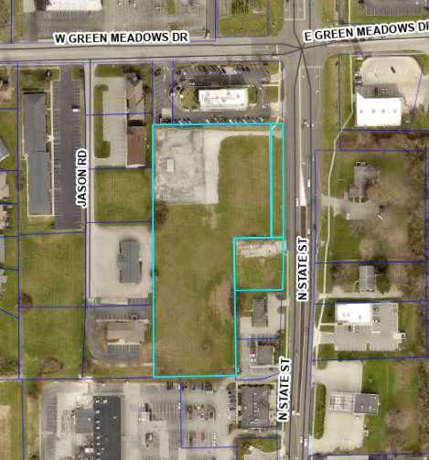 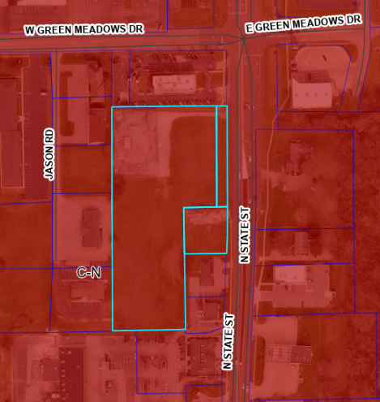
Aerial Map Zoning Map, Commercial North
North Commercial North – McDonald’s
South Commercial North – Life Choices Women’s Center
East Commercial North – Vet Clinic and Single Family Residence (across SR9)
West Commercial North – Gas Facility and Transportation Line

