VAR23-03 1488 N State St, Roger Ward Engineering, Agent for Greenwalt Development, requests approval of Variance of Development Standards to allow a Dumpster Enclosure to be built within the 10’ Rear Building Setback. Zoned CN Commercial North. 1.18 acres +/-.

Exhibits:
- Proposed Development Plans, file dated 5-23-23
- Primary Plat (currently proposed under SUB23-02 and slated for June 12 Plan Commission Hearing)
Location and Surrounding Uses:
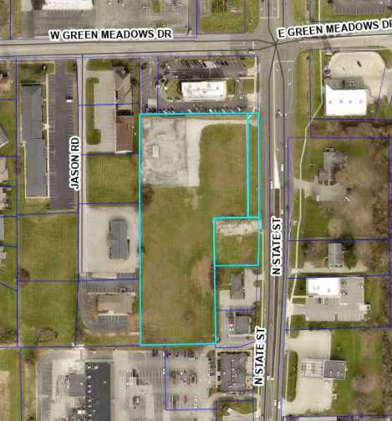 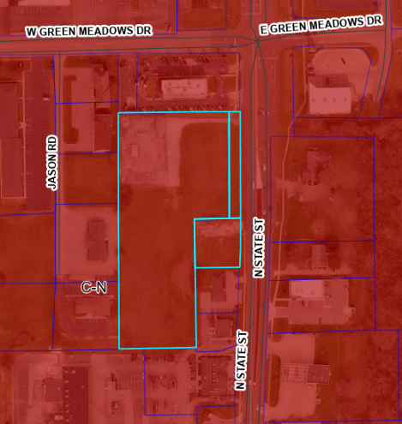
Aerial Map Zoning Map, Commercial North
North Commercial North – McDonald’s
South Commercial North – Life Choices Women’s Center
East Commercial North – Vet Clinic and Single Family Residence (across SR9)
West Commercial North – Natural Gas Facility and Transportation Line

Site History:

The southeastern portion of this area was previously a Single Family Residence along N State St which had been converted to a Medical Office. That building was torn down a few years ago, and the lot has remained vacant since. The Northwestern portion is a Natural Gas Line Facility for Center Point, which has a large Natural Gas Main Transportation Pipe running diagonally across this area underground (hence the diagonal cut to the currently proposed Primary Plat). The primary plat proposes to divide the property into 2 lots with the Centerpoint Natural Gas Facility maintaining control of Lot 2, and this development being proposed on Lot 1.
Variance Requested:
The Petitioner requests a Variance from Development Standards to allow a Dumpster with Screening Wall to be located within the 10’ platted Building Setback along the west side of the proposed development on Lot 1. The lot on which this Development is being proposed is oddly shaped and sized due to the properties and utility easements surrounding it. Specifically, the Gas Line to the west restricts the available depth of the lot, and creates the conditions which afford the most optimal location of the dumpster and screening structure to be along the western edge within the 10’ building setback. This aligns with the proposed Cross Access drive connecting the properties to the south with the parking area for this location. Therefore, this location also provides the best maneuverability for both trash pick-up and safety equipment.
Section 155.010.3.A.ii – Commercial Buildings Development Standards – Setbacks – “Setbacks shall be the minimum listed here, or the size of the applicable buffer yard required by 155.063 whichever is greater” …. “Rear Lot Line: 10 feet minimum”
The minimum and platted setback on this property for the Rear Lot Line is 10’. This disallows the erection of a permanent structure within that 10’ setback, including the screening wall for the Dumpster Enclosure.
Section 155.093 (B) of the Zoning Ordinance of Greenfield addresses variances from development standards. The Board of Zoning Appeals shall approve or deny variances from the development standards (such as height, bulk, or area) of the Zoning Ordinance. A variance may be approved under this section only upon a determination in writing that:

(1) The approval will not be injurious to the public health, safety, morals, and general welfare of the community;

Findings: The proposal would not be injurious to the public health, safety, morals and general welfare of the community. The proposed location allows for simplified and easy access for Trash Trucks to the dumpster location while keeping it visible and outside of regular pedestrian traffic. The drive also allows safety equipment to access the rear of the building and maneuver the site.

(2) The use and value of the area adjacent to the property included in the variance will not be affected in a substantially adverse manner;

Findings: The proposal would not affect the adjacent area in a substantially adverse manner. The adjacent property is unlikely to be developed further in the future due to the Natural Gas Transportation line which is in the Utility Easement that abuts the western edge of this property. The 5’ landscaping screening between properties has been deemed sufficient due to this fact.

(3) The strict application of the terms of the Zoning Ordinance will result in practical difficulties in the use of the property;

Findings: A strict application of the Ordinance would result in a practical difficulty. Due to the restrictive size and shape of this lot, there are few appropriate locations to place a Dumpster Enclosure which do not either entail potential negative impacts on public safety or require unusual and excessive expenses from the petitioner to allow for a safe location of the Dumpster Enclosure within a side or rear yard.

(4) There are exceptional or extraordinary circumstances or conditions applicable to the property or to the intended use that do not apply generally to the other property or class of use in the same vicinity and district.

Findings: Extraordinary conditions do exist for this property. Due to the restrictive size of the lot, the development plan for this location required a reduction in the Building Setback along the southwestern edge of the property from 10’ to approximately 5’ to allow for a walled Dumpster Enclosure and a Cross Access Drive between properties while maintaining sufficient depth for parking spaces, drive through and pass through lanes, and the building itself. The location of the Natural Gas Transportation Line and associated Easement dictates the shape and location of the western boundary of this property, leaving no room for a larger building setback or landscaped buffer yard along the southwest run of the property.

All variance approvals shall be considered to be conditional approvals. The Board shall have the authority to impose specific conditions as part of its approval in order to protect the public health, and for reasons of safety, comfort, and convenience (e.g., to ensure compatibility with surroundings.) Variance approval applies to the subject property and may be transferred with ownership of the subject property dependent upon the provisions and conditions prescribed by or made pursuant to the Zoning Ordinance.

Section 155.093, 2, A of the Zoning Ordinance of Greenfield states that “A variance may be approved under this section only upon a determination in writing that [the above four criteria]” are met in the petitioner’s favor. If the Board does not ascertain findings in the Petitioner’s favor in all criteria, then it may not legally approve the variance.

Staff Recommendation:

Approve Variances of Development Standards to permit the building of a Dumpster Enclosure within the 10’ Building Setback and 10’ Landscaping Buffer along the western Rear Lot Line as indicated on the Development Plan file dated May 23, 2023 with the following condition:

- All necessary permits be obtained.

