DEV25-06 Approx. 121 and 219 Pennsylvania St, The Yard at Depot Park LLC requests approval of a Development Plan to construct two mixed use buildings and a parking garage on the NE and SE corner of Pennsylvania St and the Pennsy Trail.
Exhibits:
- Plan Commission Packet dated January 13, 2025
Location and Surrounding Uses:
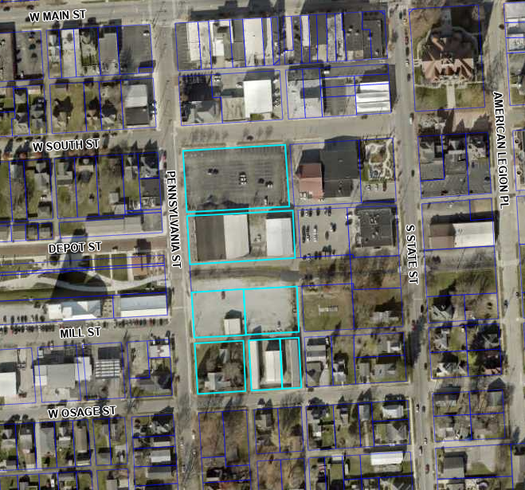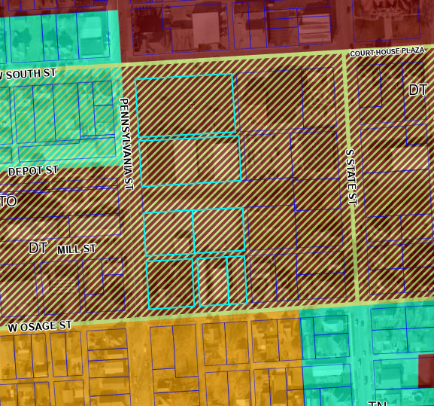

Aerial Map Zoning Map
North DT - Downtown
South RU – Residential Urban
East DT - Downtown
West DT – Downtown and TN – Traditional Neighborhood

Background:

The project sits in the DT – Downtown Zone and also falls within the RTO – Recreational Trail Overlay. The site was identified as far back as the 2013 Downtown Revitalization Plan as an area where a mixed use anchor should be for the Downtown. The proposal today is largely in line with that original vision, providing housing and commercial opportunities with a parking garage. The “urban park” was the basis for Depot Street Park’s amphitheater, which was put along the Pennsy Trail instead of the north end of this site.
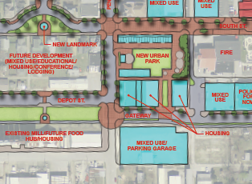

One of the driving goals of the Revitalization Plan was to create one or more “anchors” in the downtown that brought more people to live and work there. This proposal is directly in line with that and will put more people within walking distance of the local shops, restaurants, and city services. Adding living spaces that have convenient access to these local businesses is, in staff’s opinion, a critical component to the continued revitalization of the Downtown. The buildings are also located directly on the Pennsy Trail and will have various bike parking locations in and around the building as well as storage for residents.

The new Comprehensive Plan also calls for redevelopment along the Pennsy Trail to include multi-story and mixed-use buildings. An excerpt from the plan can be seen below.
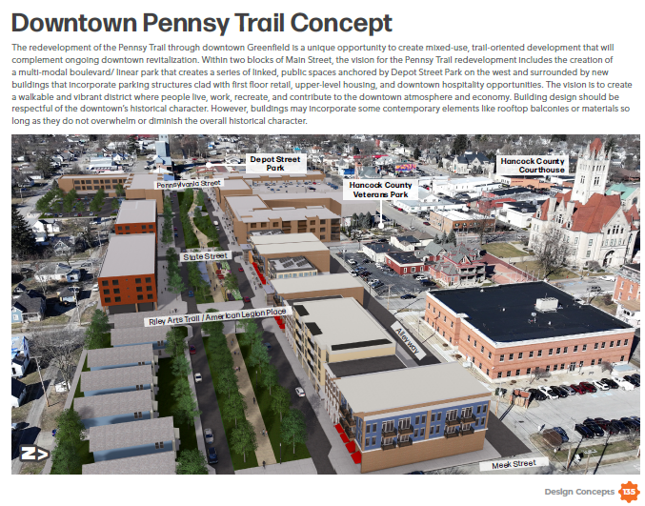

Along with being in line with the Revitalization Plan and Comprehensive Plan, this project is part of a regional plan for READI, a state initiative that provides some funding for regionally-significant projects. Greenfield is part of CIRDA, the Central Indiana region. This project is in the final approval stages for that funding as well. Various approvals have been completed with Greenfield’s Redevelopment Commission in regards to this project.

Current Development Plan Proposal
The current Development Plan Proposal is to construct two mixed-use buildings, a parking garage, and a surface parking lot. Landscaping along the Pennsy Trail will be added as well. The parking garage entrances will be on South Street, keeping some consistency for previous users of the parking lot. A mix of residential and commercial uses will be on the first floor of the buildings, with residential units above.

The design of the building is meant to complement the downtown through some of the architectural touches but not in such a way as to look overly “faked” or “theme park”. The arches and lighter materials are a nod to the Courthouse and other buildings, while a mix of materials brings in some architectural diversity that the Recreational Trail Overlay was built to accommodate.

Tech Review

Tech Review for this proposal was held multiple times, allowing departments to review plans are various stages of partial completion. Many of the technical review comments have been resolved, and some remain in progress working out final details with storm water and drainage. It is anticipated that as part of this project, a larger section of new stormwater pipe will be installed from this site heading east as a way to improve overall flow in the storm system. The applicant is continuing to work with the Wastewater Department as well to determine the best methods and treatments for the garage run-off. As is common with Development Plan projects, a recommended condition is proposed with this staff report that all remaining technical review comments be addressed prior to a permit being issued.

Access

This project is directly positioned on South Street, Pennsylvania Street, and Osage Street. Access to and from the garage and surface parking lot will be via those existing streets.

In general, the Plan Commission must be satisfied that the development meets the following five premises:
- Compatibility with surrounding land uses
Findings: This area is zoned DT and is a mix of commercial and residential uses. The “bulkier” portion of the development is on the north lot. This, paired with the L shape of the southern building and surface lot location, help step the site back down toward surrounding single and two-story buildings.

- Utility availability-
Findings: All appropriate utilities are available at the site as this is redevelopment in the downtown core. The applicant continues to work through remaining technical review comments to finalize the exact details of each utility as this project includes our first parking garage. Various water, wastewater, and storm improvements will happen as part of this project.
- Traffic Management that is favorable to health, safety, convenience, and the harmonious development of the community-
Findings: As this project is occurring on existing streets and is assessed Road Impact Fees, staff does not have concerns around traffic management. The garage will have entrance and exit points clearly marked. A Traffic Study has been provided to INDOT as many of the impacted intersections are under their jurisdiction and any timing changes to surrounding traffic lights, as one example, will be under their determination.

- Vehicular and pedestrian circulation on-site, with appropriate tie-ins to adjacent public circulation systems -
Findings: Staff finds that there will be no negative impact on the ability of vehicles or pedestrians to navigate to, through, or around the site. The site is along the Pennsy Trail and in a very walkable area of the downtown, with good connectivity to local businesses.

- Compatibility of scale, materials, and style of improvements with the surrounding area. The style of the architecture of the buildings and structures proposed to be constructed shall be subject to the approval of the Plan Commission. The approval shall be based on the architectural style creating or continuing a unified design which will be in character and proper relationship to the surrounding areas.

Findings: The building design is meant to give a nod to the downtown and courthouse through the use of light materials and arched features, while bringing in modern touches and materials that are promoted in the Recreational Trail Overlay.

Staff Recommendation: Approve the Development Plan for a mixed-use multi-unit structure, parking garage, and surface lot, subject to the findings in the staff report and the following conditions:

- All signs shall follow, adhere to, and be in compliance with UDO Sign Regulations and generally follow the submitted sign areas and locations provided as part of the application.
- All remaining technical review comments will be resolved prior to a building permit being issued.

