17 W. South ST, Greenfield IN (317) 477-4430

GREENFIELD FIRE TERRITORY

**2024 4th Quarter Write-Offs**

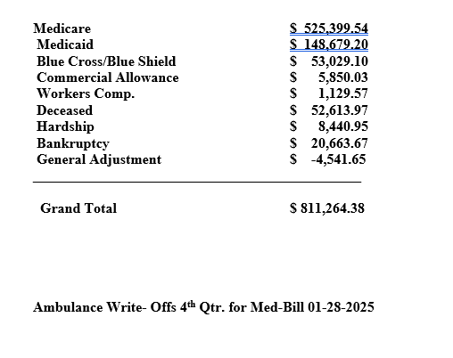

**2024 Year End Totals**

TOTAL INVOICED - $5,079,814.11

TOTAL WRITE-OFFS - $3,375,381.11

TOTAL RECEIPTS - $1,653,511.71