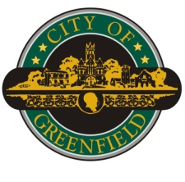

*Department of Engineering*

**November 12, 2024**

Board of Public works & Safety

10 South State Street

Greenfield, IN 46140

Dear Members,

The developer of Evergreen Estates Section 1, Greentree Development, LLC, has completed the installation of work listed below and is requesting the acceptance of the improvements and the release of the performance bonds associated with the work.

Listed below are the Performance bonds requested to be released:

Street Signs and Lighting LICX1979776

Lot Corners and Monuments LICX1979767

Listed Below are the Maintenance Bonds requested to be accepted:

Street Signs and Lighting LICX1983089

Lot Corners and Monuments LICX1983088

Staff has inspected an approved the above-listed improvements, therefore I would like to request the Board accept the work shown above and release the performance bonds on file in the Clerk Treasurer’s office. Upon your acceptance, the performance bonds will be swapped out for the required 3-year maintenance bond as soon as possible.

Sincerely,

Glen Marrow, PE

City Engineer