Thursday, August 13, 2024

NOTICE TO PROCEED

To: Rundell Ernstberger Associates
618 E Market St
Indianapolis, IN 46202

COMPREHENSIVE PLAN UPDATE

Contract Executed: Greenfield Board of Works Meeting, August 13, 2024

Type of Contract: Professional Services Amount of Contract: $160,000

You are hereby notified to commence work on Framework Phase of the above referenced project on February 2, 2024 and the Visioning Phase on August 1, 2024. Work shall be completed according to the Contract Form for the above project with the understanding that with final deliverables for each phase a change order for the Substantial and Final Completion Date, may be submitted, commensurate with the start and end date, as outlined in Schedule D.

Date: this 13th day of August, 2024

ACCEPTANCE OF NOTICE

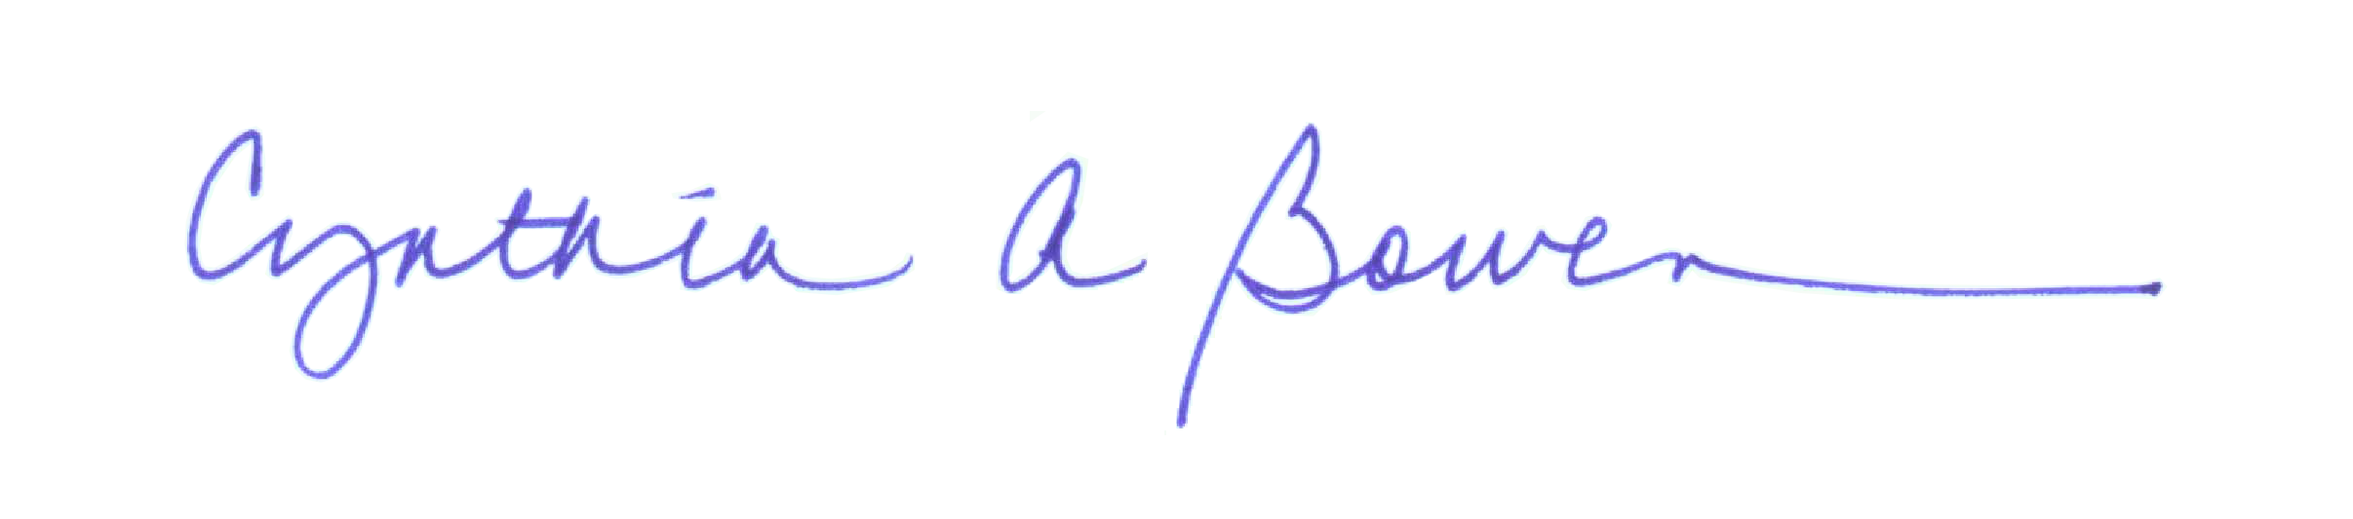
Receipt of the foregoing Notice to Proceed is hereby acknowledged:

By: _______________________________________________________
Partner
Title _______________________________________________________
Cynthia A. Bowen
Printed: ______________________________________________________

This _______ day of ___________, 2024

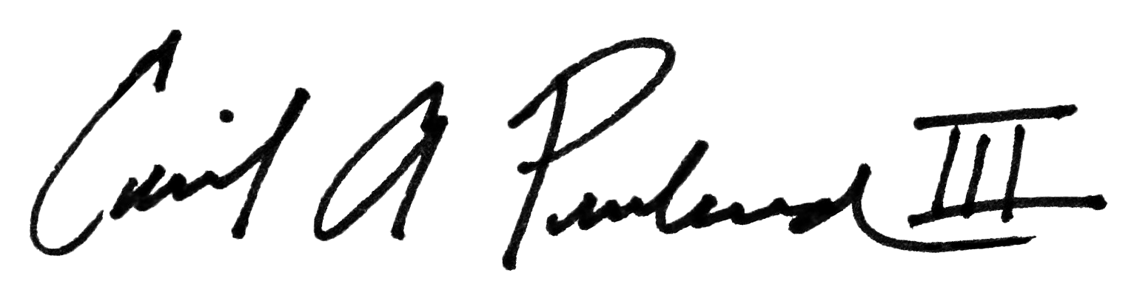
Attest:

By: _______________________________________________________
Cecil Penland
Printed: ______________________________________________________

This _____ day of ___________, 2024

